
FACULTY OF ENGINEERING AMD TECHNOLOGY DEPARTMENT OF COMPUTER ENGINEERING

CEF440: INTENET PROGRAMING AND MOBILE PROGRAMING
Instructor: Dr. Valery Nkemeni

Presented by:
NAME | MATRTICLE
TEBOH MANOIELLA | FE23A167
EBONG THIERRY | FE23A039
EBONG VALITINE | FE23A038
LUIGI-GONZAGA | FE23A084

- INTRODUCTION:
The primary objective of this phase was to identify the technical and user-centric requirements for a mobile application capable of identifying network "dead zones" in Cameroon. Through a combination of stakeholder identification and a survey of 50 mobile users, we have established a clear set of functional and non-functional requirements that will guide the development phase.

- Methodology
- Stakeholder Analysis: We identified 4 primary groups
  - End Users (Data providers): People who will install the app. Their main concern is battery life and privacy.
  - Network Operators/Engineers: The primary "clients" who need the data to fix coverage holes (MTN/Orange/Camtel).
  - Developers: Responsible for building and maintaining the system.
      - Regulatory Bodies: Entities concerned with data privacy (like GDPR or local telecommunications laws).
- Data gathering:
- Surveying: A 12-question digital survey was distributed to capture device demographics, network performance, and user reluctance factors.
  - Like to google form:
https://docs.google.com/forms/d/e/1FAIpQLSemUDI27DlZOatGpBDcs0f5lw7hFmc16amt3g6Zpo0XnYS5Vg/viewform?usp=header
- Interviews/Surveys: Ask potential users if they would be willing to run a background app in exchange for better network service.
- Brainstorming: Regular meeting sessions were held to discuss and list the technical matric we need.
- Reverse Engineering: We looked into am existing app (Speedtest by Ookla ) that serves the same purpose as our intended application. This approach help us find hidden requirements. We saw that it uses the "Two-Pronged" Approach (Foreground: using a Go button and background data collection). We also saw that for Anonymization, they aggregate data into "Tiles" (approx. 600m x 600m areas). This means they can show a "dead zone" on a map without showing exactly which house the user was in.

- Data Cleaning: Raw responses were standardized and filtered for outliers to ensure statistical accuracy.
Key Functions used:
- TRIM(): Removes extra spaces at the beginning or end of text (e.g., " MTN " becomes "MTN").
- PROPER(): Capitalizes names correctly (e.g., "samsung" becomes "Samsung").
- Remove Duplicates: All double entries were removed.
- Filter: Highlighting the top row and turning on "Filters" lets us quickly see if anyone gave "outlier" answers (like 100% battery drain).

3. Key Findings & Data Gathering
- Network Performance (The Problem)
The data confirms a significant need for this application:
- Stability Rating: The average perceived network stability is only 2.84 / 5.
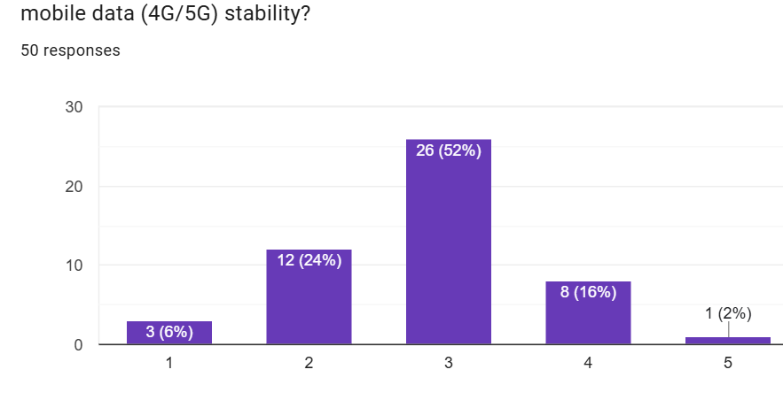
- Dead Zone Frequency: 50% of users report encountering dead zones multiple times a day, with another 38% encountering them occasionally.
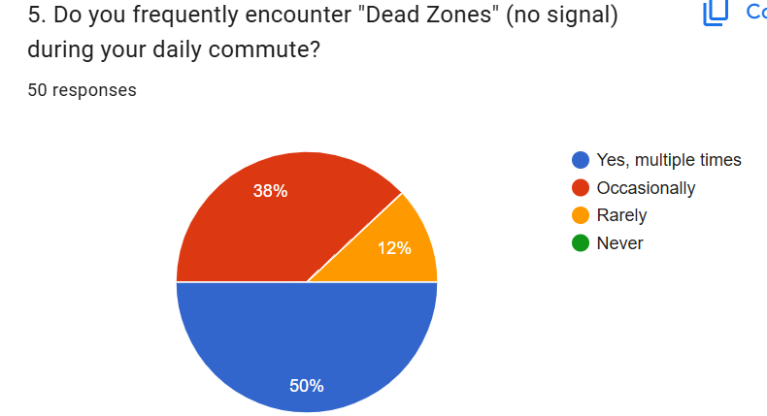

- Hotspots identified: Respondents frequently cited areas such as Bomaka, Molyko, and University Gates as high-failure zones.

b. User Reluctance & Privacy
Privacy is the biggest barrier to adoption:
- Concern Level: Users reported a high privacy concern average of 3.70 / 5.
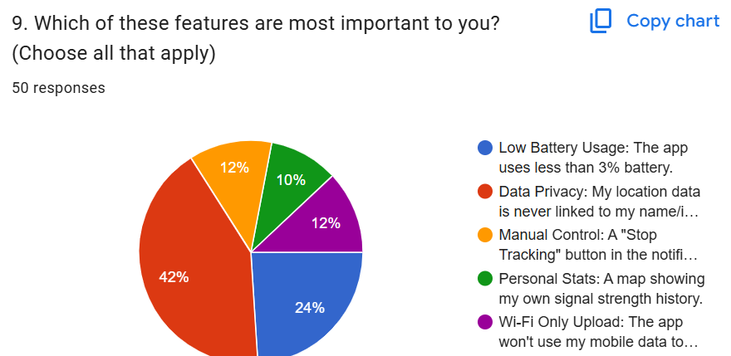
- Condition for Participation: While a majority are willing to help, a significant segment will only participate if they can view the data collected from their own devices.
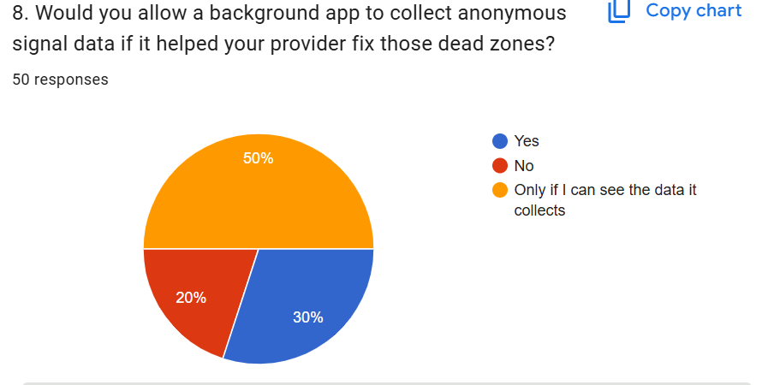
C. Technical Constraints
- Platform: A majority of respondents use Android, making it the primary target for the MVP (Minimum Viable Product).
  - 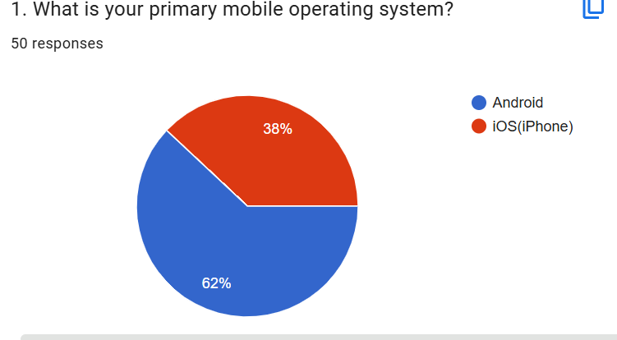
- Data Limits: Most users are willing to contribute 10MB–50MB of data monthly, though a preference for "Wi-Fi Only Upload" was noted.
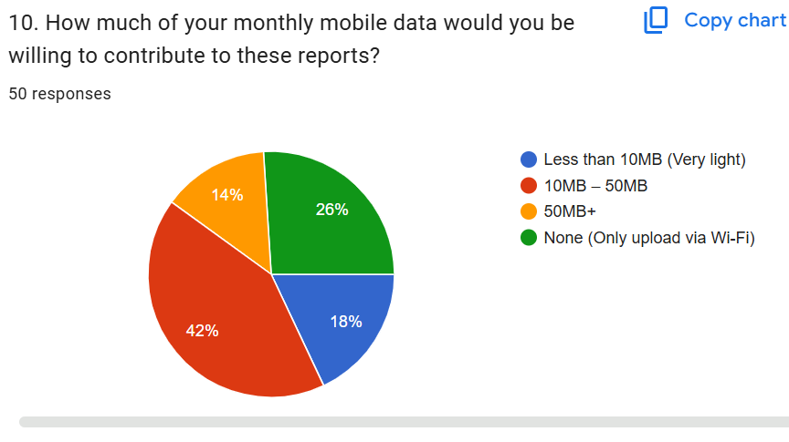

Finalized Requirements
- Functional Requirements (FR)
- Automated Signal Capture: The app must automatically record RSRP, RSRQ, and Cell ID at set intervals.
- GPS Tagging: Every signal measurement must be linked to precise GPS coordinates.
- Local Storage (Offline Mode): Measurements must be stored in a local SQLite database when the user is in a dead zone and uploaded once connectivity is restored.
- User Dashboard: Users must be able to view a map of their own signal history (to satisfy the transparency requirement).
- Non-Functional Requirements (NFR)
- Efficiency: Battery consumption must remain below 3% of total daily usage.
- Anonymity: No Personal Identifiable Information (PII) like names or phone numbers shall be transmitted.
- Data Usage: Background data transmission must not exceed 50MB per month unless on Wi-Fi.
- Reliability: The background service must restart automatically if the phone is rebooted.

6.Conclusion & Next Steps
The requirement gathering phase successfully validated the project's utility. The high frequency of dead zones (88% total) proves that current "Drive Testing" by operators is insufficient.
Next Step: Proceed to Task 3: Requirement Analysis, where we will translate these needs into System Architecture diagrams and Use Case models.

